User Journey & Feature List

# **User journey**

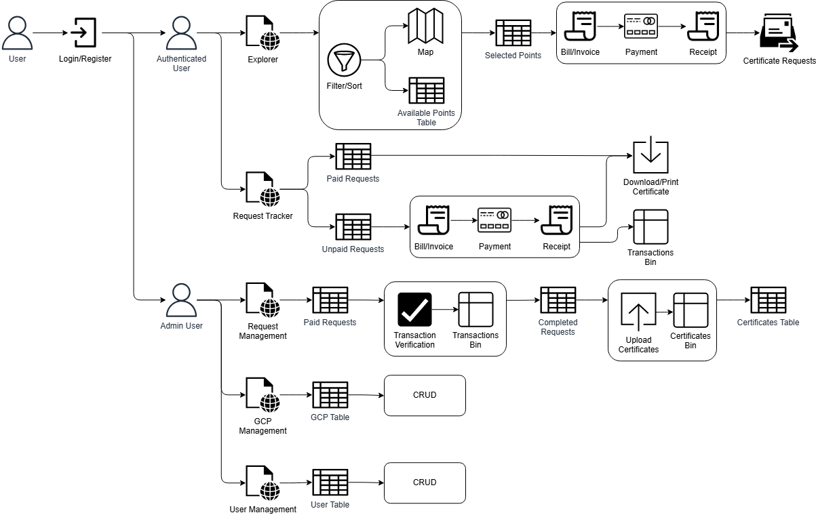

# **Features list**

| **Existing** | **Possible additions** |
| --- | --- |
| 1. GCP repository (frontend)    1. Explorer       1. Composition of the page       2. Map component       3. Table component          1. Available points          2. Selected points       4. Sidebar component          1. Selected points          2. Tools          3. Request/Download buttons          4. Filter/sort component    2. Tracker (planning to be replaced by 1c on **Possible additions**)    3. Management       1. Control Points          1. Add Points          2. Delete Points          3. Edit Points       2. Certificates          1. Process Requests    4. General       1. Navigation bar       2. Footer 2. UI/UX for database tables (backend)    1. GCP table (CRUD)    2. Request table    3. User table 3. File bin/s    1. Certificates    2. Proofs of transaction    3. Receipts/invoice | 1. Account / User Authentication    1. Login    2. Admin Powers    3. Requests Log/Page 2. Transactions form/page    1. Billing form/s    2. Proof of Payment form 3. Stronger relational structure for database 4. Possible integration or further improvement of the Simulator (might be out-of-scope) 5. Reduction of button clicks to achieve use-cases    1. GCP description download    2. GCP certification request submission    3. GCP certification request tracking    4. Certificate approval    5. GCP metadata CRUD 6. Improvements on **1, 2, and 3 on Existing features** 7. Issues, requests, comments, feedback features for various cases (account issues, lost GCPs, certificate issues) |

Feedback / Recommendations

# **Feedback & recommendations**

| **Frontend** | **Backend** |
| --- | --- |
| 1. Improvements in UI/UX    1. Explorer       1. Composition of the page       2. Map component       3. Table component          1. Available points          2. Selected points       4. Sidebar component          1. Selected points          2. Tools          3. Request/Download buttons          4. Filter/sort component    2. Tracker    3. Management    4. General       1. Navigation bar       2. Footer 2. Reduction of button clicks to achieve use-cases    1. GCP description download    2. GCP certification request submission    3. GCP certification request tracking    4. Certificate approval    5. GCP metadata CRUD | 1. Stronger relational structure for database 2. UI/UX for database tables    1. GCP table (CRUD)    2. Request table    3. User table 3. File bin    1. Certificates    2. Proofs of transaction    3. Receipts/invoice |